 TRIBHUVAN UNIVERSITY

INSTITUTE OF ENGINEERING

PULCHOWK CAMPUS

# 

# **REPORT ON BRICK BREAKER**

Date: 5th Bhadra, 2079

**SUBMITTED BY: SUBMITTED TO:**

Prajjwal Pandey(077BCT055) Department of Electronics and Computer

Prasun Sitaula(077BCT057)

# **ACKNOWLEDGEMENT**

Knowledge is not just limited on our books and our words; it differs on our experience, on a way we face the time and situation that passes across us. The project work on C++ is an excellent way to collaborate the knowledge in our mental altitudes in computer sector.

We would like to express my sincere gratitude to all the personalities who played a supportive role in bringing this project to the height of success. First of all, we would like to thank **our parents** who helped us a lot by providing suitable environment, accessories, economic support, etc. required for the project. Secondly, we would like to express our thanks of gratitude to subject teacher and computer instructor **Mr.Daya Sagar Baral** who provided us a golden opportunity for creating a project in C++ and are also thankful for his help and guidance. Besides, we would like to thank **college management** too. Finally, we extend our gratitude to our fellow programmers worldwide who helped a lot in getting new ideas and other helpful hands that helped us a lot in finalizing this project within the limited time frame.

I am also grateful for the insightful comments offered by our friends. The generosity and expertise of one and all have improved this project in innumerable ways and saved us from many errors.

Computer is an integral part of our life. Only theoretical development in Computer doesn’t necessarily bring positive impact in computer sector. Practical portion are indispensible also for the development in the computer sector. By doing this project, we really developed our skills related to different uses and applications of Object Oriented Programming.

Really, this project is **“an excellent example of a coordinated and united team and other** **helpful faces and hands.”**

# TABLE OF CONTENTS

1. INTRODUCTION…………………………………………………4
2. OBJECTIVES………………………………………………….….5
3. APPLICATION…………………………………………………...6
4. IMPLEMENTATION…………………………………………….7
5. LITERATURE SURVEY…………………………………………8
6. DEVELOPED SYSTEM………………………………………….9

I.SYSTEM BLOCK DIAGRAM

II.BLOCK DIAGRAM

1. METHODOLOGY……………………………………………….10
2. RESULTS………………………………………………………..11
3. PROBLEMS FACED AND SOLUTIONS………………………12
4. LIMITATIONS AND FUTURE ENHANCEMENTS…………..13
5. CONCLUSION AND RECOMMENDATIONS………………...14
6. REFERENCES…………………………………………………...15

# INTRODUCTION

Brick Breaker project is a minor project proposal for our academic session B.E. (computer) Second Year First Part as prescribed in the syllabus. The main aim of this project is to develop a user-friendly program using an object oriented programming language, C++.

Brick Breaker, is a 2D shooter game where user tries to smash a wall of bricks by deflecting a bouncing ball into it while aim is assisted by paddle. The game is simple shooter genre but has a cult of professional players trying to achieve high scores. The game is based on C++ using SDL(Simple DIrectMedia Layer) as a development library. At present, there are many similar games at various online platforms with different names and is very popular for being simple and competitive at the same time. Bricks Breaker may be an old game but it is still endured by many people, both children as well as adults. During the game development it brings back our old memories and while playing this game will take us back to our wonderful childhood.

This program might not compete with the program made by the mainstream developers but serves as a introducing medium for us wit challenging shooter game in LAN, as we approach learning complex programming. Also, it is fun to play.

# OBJECTIVES

* To create an Object Oriented Programming(C++) based program.
* To explore features of C++ Language and SDL development Library.
* To be familiar with resource re-usability by making user defined header files.
* To learn basics of game development and game physics.
* To introduce ourselves with graphics programming in game development using SDL.
* To build an attractive UI so as to ease users while playing game.
* To understand the scope of OOP in major project development.
* To develop research, team work and communicative skills.

# APPLICATION

This program has lots of opportunities in real world. Since, we are just beginners in the field of game development, our project might not compete with the bests of its version but serves as a source to put our knowledge that we have gained over the course of study and somewhat seems fun to play as well.

The game gives old retro vibe, so it a retro gamer is sure to enjoy it. Hence, it will be best to say that this program will introduce us to challenges we are going to face when we work in real world and deal with similar obstacles that we would face. Hence, this will act as an experience enhancer and project development knowledge.

# IMPLEMENTATION

The game starts with menu that consists of Play Game and Exit.

1. **Play Game**: This takes user to the game window where the user plays game.
2. **Exit**: This exists the game.

**Game Window**:

In this window the code related to game runs. There are two windows for two levels of game. First level is comparatively easier to clear however, the second level is comparatively faster and difficult to clear.

**Game Ba**r:

It consists of score and lives count. Score says how many bricks the user has broken and lives count shows number of bricks the user destroyed while playing the game.

**Note**: The user can manually switch between the levels by clicking on the next symbol button at the top left corner of the game window.

Basically, following methods were implemented for the completion of the project:

1. Study, research and analysis
2. Proposal Submission
3. Designing of the layout of the project
4. Coding
5. Testing, Modification, Documentation

# LITERATURE SURVEY

For this project, we read different books as well as documentation in internet. Books like “The Secrets of Object Oriented Programming”, “SDL Game Development”, etc. were very beneficial as well as effective to tackle problems and develop knowledge in the game development.

But only hard copy weren’t sufficient and since we were using SDL for first time we had no prior knowledge in using it also, it didn’t had any official documentation available in internet. So, we viewed various e books and different tutorials from YouTube.

### **DEVELOPED SYSTEM**

### **DESCRIPTION**

Bricks breaker originally known as Arknoid, is a fun game in which the player breaks the bricks with a ball which can bounce from a paddle located at the bottom which can move horizontally. This game will remind you of the classic arcade games of your past. The player objective is to break all the colored bricks on each level. I order to break a brick, you must hit it with the ball. Some bricks may take more than one hit to break. Use the paddle to avoid the ball from falling to the bottom of the screen. The angle at which the ball bounces off the paddle depends on the point at which the ball hit the paddle. Move the paddle side to side using the mouse and use space to fire the laser when you have the power. But, if the ball hits the bottom enclosure, the player loses and the game ends.

This game features different levels with different difficulties. The player will have 3 lives. A live will be lost if the ball misses the paddle at the bottom. If all lives are lost than, the player loses the game. The player gets points by breaking the brick. Once the player breaks all the bricks, the player will be advanced to a harder level. This game will also feature some unbreakable bricks which will act as barrier for the ball. This game will also have tutorial to teach a new player for playing.

### **BLOCK DIAGRAM**

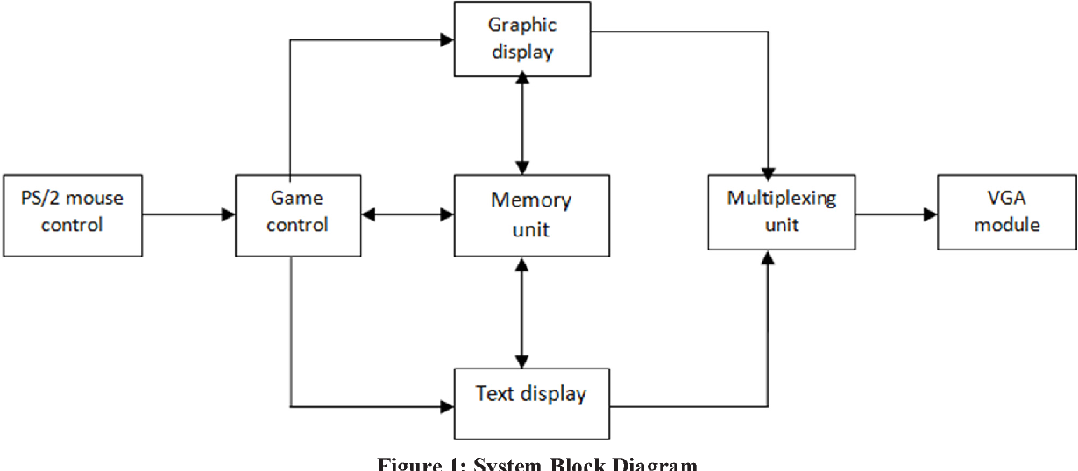

# METHODOLOGY

The project is based on C++ programming language utilizing SDL graphics library and “Object Oriented Programming” concept. The program uses the concept of code classes, functions, re-usability, data abstraction . Similarly, C++ has the ability to manage the memory allocation/de-allocation on any objects that we’ve created which can increase the performance of our game.

Game is performance critical software that requires 100% usage of the hardware user has, and c++ is only popular language that gives you such abilities:

* High abstraction level : fine object oriented and generic programming
* Very good and determinism control of the resources you use.
* Ability to optimize special parts to very high level that is almost impossible to achieve with other popular languages.

The strength of C++ when it comes to game development is the ability to exactly layout the data-structures that your software will use. C++ provides the ability to override important performance bottlenecks such as memory allocation. It has the ability to structure and place things exactly where wanted in the memory. On top of this it’s a flexible programming language that provides a decent development velocity.

Since, Visual Studio Code is one of the most popular IDE and both of us are familiar are familiar with it so we decided to use VSC(version 1.68.1) which uses GCC compiler(version 12.1.0) and GDB(version 12.1.0) as debugger. Similarly, SDL is to be used for graphics and other game related works as program calls for complex programming and SDL provides best high resolution 2D graphics development.

Hence, Programming methods to be used can be summarized as:

* Proposal Submission
* Analyzing and Learning the concept
* Discussing the challenges
* Scheduling the project
* Coding the program
* Execution and testing
* Debugging
* Program Documentation

**RESULTS**

With the completion of the project, the game was successfully developed as per the plans initially thought as well as some modifications were made too. This project developed experience as well as knowledge in game development and object oriented programming.The complete game was designed with necessary features.

The main objectives were all obtained however, still some features couldn’t be implemented as planned which might be due to time constraint.

However, this project developed sense of team work and cooperation between the members. This taught us to share knowledge and solutions during program development.

**PROBLEMS FACED AND SOLUTIONS**

Though the program development completed on time but it cost a lot of efforts due to lots of problems and errors faced during the development of the game and solutions to the problems were obtained by discussing with classmates and teachers. Also, tutorials in YouTube and other online platforms which provide assistance and help in learning OOP.

So, the problems faced during the development of program were:

1. We didn’t have any prior knowledge to OOP development in SDL before program development. So, it’s obvious to face syntax and execution errors.
2. SDL doesn’t have its official documentation so, it’s difficult to gather much information directly about use of it.
3. There may be few the members have different IDE’s for example Visual Studio Code, Visual Studio or Code Blocks.
4. The physics on reflection of object after collision was main part to tackle. That took some time to figure it out but it was carried out effectively.
5. It’s difficult to find the copyright free textures like background, sound effects.
6. Linker problems and many more.

**LIMITATIONS AND FUTURE ENHANCEMENTS**

As we’ve completed the game by the deadline, however many features could be further added to enhance the beauty and productivity of the game. This includes:

1. Multiple Levels
2. Level jump after completing present level
3. Pausing the game
4. Custom level Creation
5. Game Boosters
6. Bricks visual texture and many more.

**CONCLUSION AND RECOMMENDATIONS**

This project was definitely an effective way of learning and implementing knowledge in practical project developments. It taught us to implement library in program development for example SDL which was used in the development of this game. This was the very first project which was developed using knowledge which we learnt during the course of time in lab and lab exercises. Proper analysis of the topic is required prior to anything during program development. So, it taught us in a way to gather info about the project and everything else that we require for project development. The basics steps for program development like analysis, proposal submission, coding, testing, modification,etc. were all followed which helped to gain such experiences which are have great essence in project development in real world. During program development it takes lot of attention while linking files.

Hence, the project was successfully developed.

**REFERENCES**

* Daya Sagar Baral and Diwakar Baral, “The Secrets of Object oriented Programming”, Bhundipuran Prakasan
* Josh Lospinoso, “C++ CRASH COURSE”, No Starch Press
* Shaun Mitchell, “SDL Game Development”